An advisory commission of the Coastal Protection and Restoration Authority
cOASTAL LOUISIANA LEVEE CONSORTIUM

Amite River Basin Drainage and Water Conservation District

Atchafalaya Basin Levee District

Office of the Governor-Coastal Activities

Chenier Plain Coastal Restoration & Protection Authority

Grand Isle Independent Levee District

Iberia Parish Levee District

Jefferson Davis Parish Government

Lafitte Area Independent Levee District

Lafourche Basin Levee District

Non-Flood Protection Asset Management Authority

North Lafourche Conservation, Levee and Drainage District

Plaquemines Parish Government

Pontchartrain Levee District

The Sewerage and Water Board of New Orleans

South Lafourche Levee District

Southeast Louisiana Flood Protection Authority—East

Southeast Louisiana Flood Protection Authority—West

St. Mary Levee District

St. Tammany Levee District

Terrebonne Levee and Conservation District

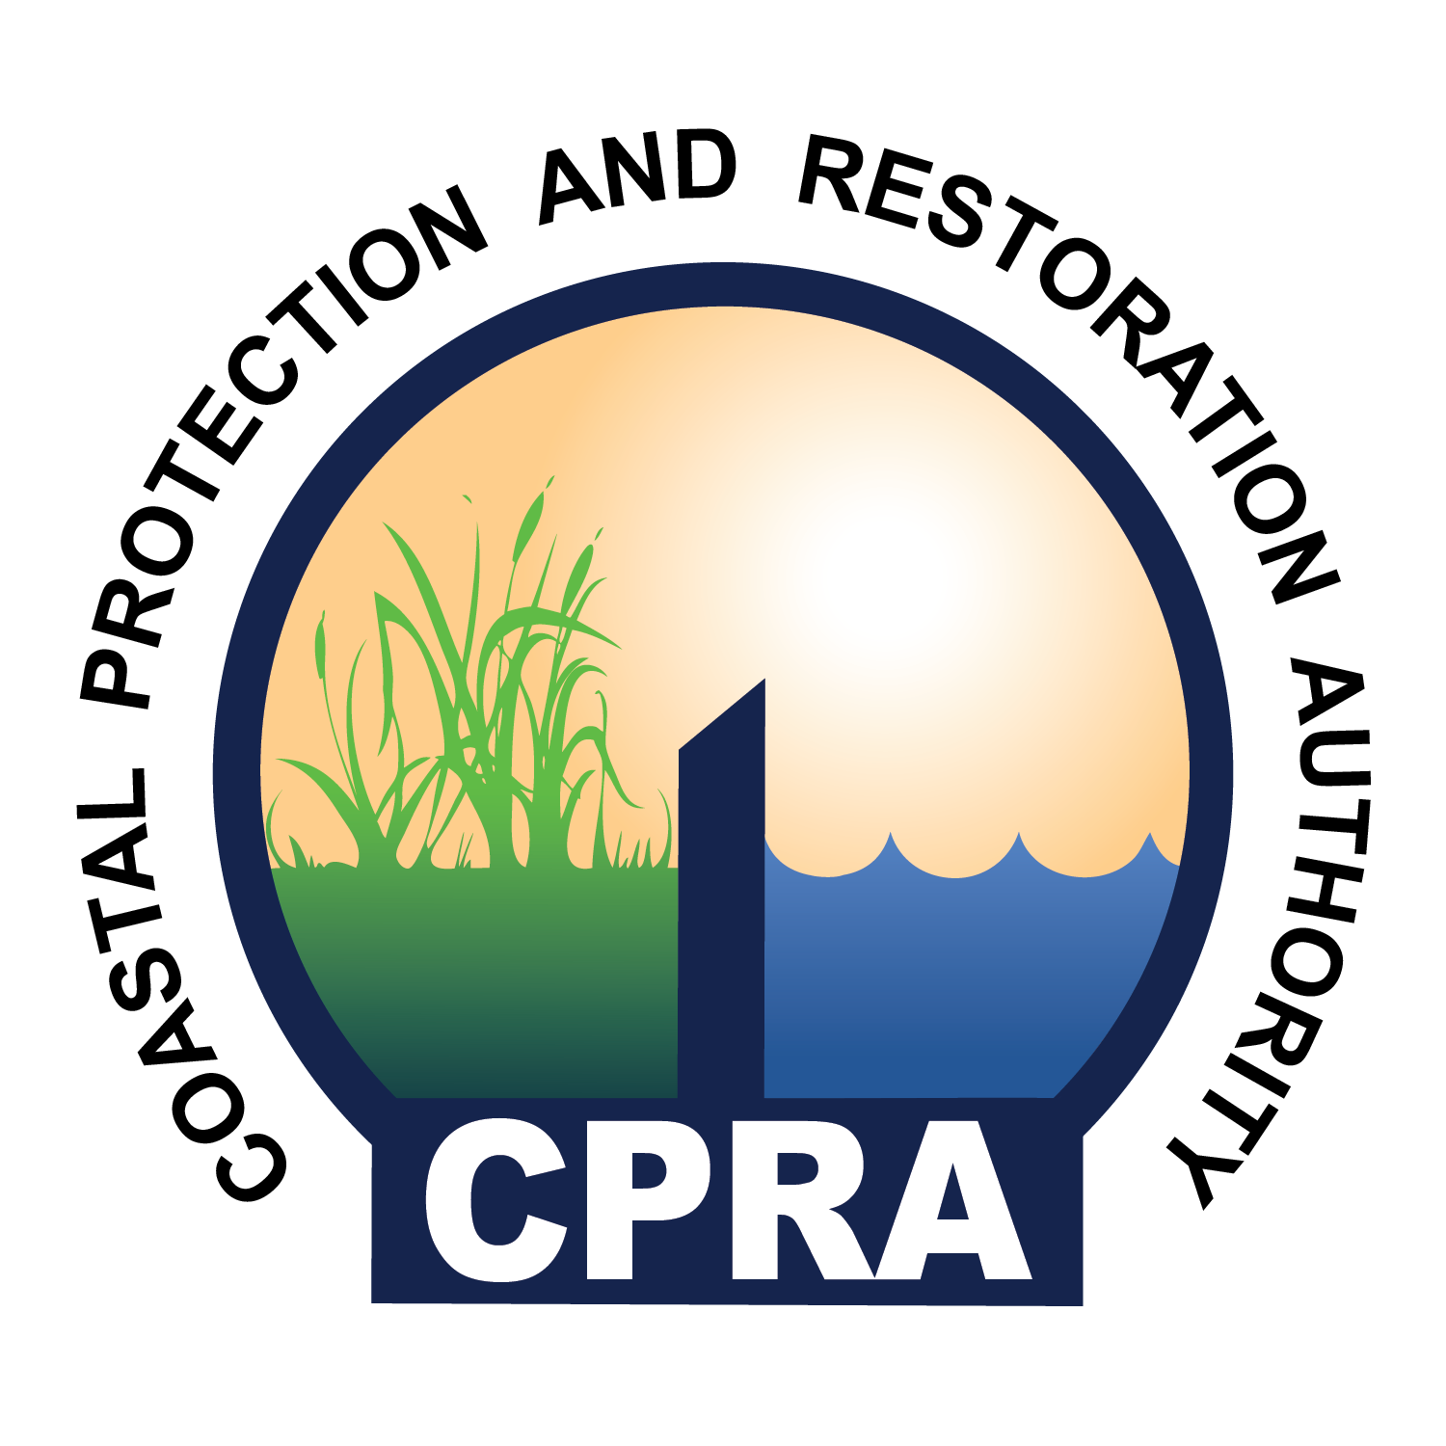

900 North Third St. 4th Floor
Baton Rouge, LA 70802
Levee Consortium Meeting
Galvez Building, Oliver Pollock Rm
602 North 5th Street, Baton Rouge, LA

Thursday, November 12, 2015
1:30 P.M.

- Call to Order – Windell Curole
- Roll Call
- Approval of Agenda
- Approval of Minutes
- The Limitations of NFIP Estimates for 100-yr Storm Surge and Associated Levee Design Criteria – Bob Jacobsen
- Hurricane Protection System and Evacuation – Windell Curole
- Discussion of possible coastal legislative issues for 2016 – Reggie Dupre
- Discussion of levee district expenses for interstate organizations – Reggie Dupre
- Discussion of possibly having LA CPRA handle, on behalf of levee districts, governmental relations regarding the next renewal of NFIP – Reggie Dupre
- Court Ruling on WOTUS – Dwayne Bourgeois
- USACE MVN LRAM mitigation assessment method – Dwayne Bourgeois
- NFIP / LAMP / TMAC updates – Dwayne Bourgeois
- FFRMS – Dwayne Bourgeois
- Atchafalaya Basin River and Bay Issues – (Bill Hidalgo or Tim Matte)
- Public Comment
- Adjourn

